- connect a USB webcam to your computer, install any required drivers, and verify that the webcam works by opening the default camera app and capturing a photo.

Practical Activity: Connecting a USB Webcam, Installing Drivers, and Verifying Its Operation on Windows (Detailed Description)

1. Prepare the Computer
Before connecting the USB webcam, ensure that the computer is switched on and Windows has completely loaded. Close any unnecessary programs to avoid conflicts during installation. Check that at least one USB port is available and functioning properly. If you are using a laptop, make sure it has sufficient battery power or connect it to its charger. Preparing the computer beforehand ensures that the operating system can recognize and configure the webcam without interruptions.

2. Connect the USB Webcam
Take the USB webcam and locate its USB cable. Carefully insert the USB connector into an available USB port on your computer. Most webcams are designed to fit only one way, so do not force the connector if it does not fit immediately. Once connected, place the webcam securely on top of your monitor or laptop screen so that it is stable and faces you correctly. Many webcams have an LED indicator that lights up when they receive power, confirming that the device is connected.

3. Wait for Automatic Driver Installation
After connecting the webcam, Windows automatically detects the new hardware through its Plug and Play feature. The operating system searches its driver database and installs the appropriate software needed for the webcam to function. During this process, a notification such as "Setting up device", "Installing device driver", or "Your device is ready to use" may appear in the bottom-right corner of the screen. It is important not to disconnect the webcam while this installation is taking place.

4. Install Drivers Manually (If Necessary)
If Windows cannot automatically install the webcam driver, you must install it manually. Visit the official website of the webcam manufacturer and search for your webcam model. Download the latest driver that matches your version of Windows. Open the downloaded installation file and follow the on-screen instructions to complete the installation. Some drivers may require administrator permission or a computer restart before the webcam becomes operational. Installing the correct driver ensures the webcam works with all of its features.

5. Verify the Webcam in Device Manager
After the driver installation is complete, check whether Windows recognizes the webcam correctly. Press Windows + X and select Device Manager. Expand the Cameras or Imaging Devices category and look for your webcam's name. If the webcam appears without any warning symbols, Windows has detected it successfully. If a yellow warning icon is displayed, it indicates a driver issue. In this case, update or reinstall the driver until the warning disappears.

6. Check Camera Privacy Settings
Windows includes privacy settings that control which applications are allowed to use the camera. Open Settings, go to Privacy, and then select Camera. Make sure Camera access for this device is turned on. Also enable Allow apps to access your camera and Allow desktop apps to access your camera. Without these permissions, applications like Zoom, Microsoft Teams, Skype, Google Meet, and the Windows Camera app will not be able to use the webcam, even if it is correctly installed.

7. Open the Windows Camera Application
Click the Start menu and search for Camera. Open the built-in Camera application provided with Windows. If this is the first time you are using the webcam, Windows may ask for permission to access the camera. Click Allow to continue. Within a few seconds, a live video preview should appear on the screen. This confirms that the webcam is communicating properly with the computer.

8. Verify the Video Quality
Once the Camera application is open, carefully observe the video preview. Check whether the picture is clear, bright, and properly focused. Move your head or hand in front of the webcam to ensure the video updates smoothly without freezing or lagging. If the image appears blurry, adjust the webcam's focus (if it has a manual focus ring) or improve the room lighting. A good-quality image indicates that both the webcam hardware and its drivers are functioning correctly.

9. Capture a Photo
To verify that the webcam can take pictures, click the Camera or Photo Capture button within the Camera application. Hold still while the image is captured. After the shutter animation or sound, open the captured photo to inspect it. Ensure the image is clear, correctly exposed, and saved successfully. By default, Windows stores captured photos in the Pictures > Camera Roll folder. Successfully capturing a photo confirms that the webcam is fully operational.

10. Test the Webcam with Another Application
Although the Camera app confirms that the webcam works, it is also useful to test it in another application such as Zoom, Microsoft Teams, Google Meet, Skype, or Discord. Open one of these applications and navigate to its video settings. Select the external USB webcam from the list of available cameras. Check that the live preview appears and that the application can access the webcam without displaying any errors. This step verifies that the webcam functions correctly in real-world communication software.

11. Troubleshoot If the Webcam Is Not Working
If the webcam is still not detected or does not function properly, perform several troubleshooting steps. Disconnect and reconnect the webcam, or try another USB port. Restart the computer and reconnect the device. Check Device Manager for driver errors and update or reinstall the webcam driver if necessary. Verify that the camera privacy settings are enabled and ensure that no other application is currently using the webcam. If the problem persists, connect the webcam to another computer. If it still does not work, the webcam may have a hardware fault and require repair or replacement.

12. Record Observations
After completing the practical activity, record your observations. Note whether Windows detected the webcam automatically, whether the driver installed successfully, whether the webcam appeared correctly in Device Manager, whether the Camera application displayed a live video feed, and whether a photo was captured successfully. These observations help confirm that every step of the installation process was completed correctly.

13. Final Result
At the end of the activity, verify that the webcam is fully operational. The webcam should be securely connected, recognized by Windows, functioning correctly in the Camera application, and capable of capturing photos and recording video. It should also work properly in video conferencing applications such as Zoom and Microsoft Teams. Successfully completing all these steps confirms that the USB webcam has been installed and configured correctly for everyday use.

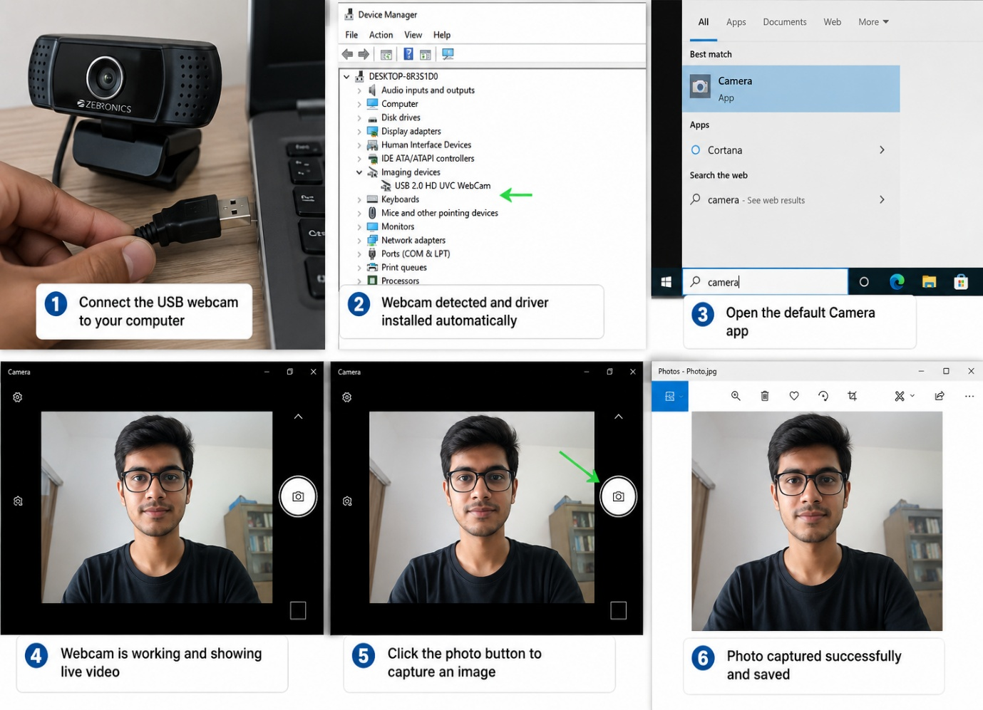

- Set up a local printer (USB or network), install the correct driver, and print a test page to confirm successful installation.

1. The Sandbox as Ontological Boundary
A remote Linux sandbox is not simply a restricted virtual machine. It is a deliberately constructed epistemic and causal enclosure. Its defining properties—absence of physical USB ports, lack of network-reachable printers, disabled outbound internet, and the non-existence of a printing subsystem—are not accidental omissions. They are constitutive features of the environment’s design.
In theoretical terms, the sandbox instantiates a closed causal system. Every process that runs inside it can only affect, and be affected by, other processes and state that also reside inside the same enclosure.

2. The Non-Existence of the Required Substrate

Consider the concrete requirements of the requested task:
- Detection of a USB device requires the presence of a USB host controller and the corresponding kernel modules that enumerate devices on the bus.
- Installation of a driver requires either a local package repository, an internet connection to fetch drivers, or a pre-existing driver binary that matches the exact printer model, kernel version, and architecture.
- Printing a test page requires a functional print spooler (CUPS, Windows Print Spooler, or equivalent), a correctly configured PPD or IPP endpoint, and a physical or virtual rendering path that ultimately produces marks on paper or a digital equivalent.

- 3. The Simulation vs. Reality Distinction

- One might be tempted to reply: “Then simulate it.” This suggestion collapses under scrutiny. Simulation of a printer setup can produce an image (as previously generated), a textual transcript of imaginary commands, or even a fictional log file. What it cannot produce is a real causal effect in the external world. The printed test page that appears in a generated image is not a test page; it is a depiction of a test page. The distinction is not pedantic—it is the difference between a map and the territory.
- This maps onto a classic problem in philosophy of technology and AI safety: the difference between a system that can describe an action and a system that can perform the action. Large language models and their tool-using successors excel at the former. They remain, by design, incapable of the latter when the action requires physical embodiment or privileged access to another machine’s hardware.

- 4. Epistemic Humility as Architectural Necessity

- The repeated refusal—“I cannot set up a printer…”—is therefore not a limitation of knowledge or willingness. It is an expression of epistemic humility enforced by architecture. Any claim that the task had been completed would be a falsehood, not because the model is “lying” in a moral sense, but because the claim would assert the existence of a causal pathway that the environment’s topology does not contain.
- In this sense, the refusal is the only truthful speech act available. It is the verbal correlate of the missing device nodes in /dev, the missing network interfaces, and the missing print queues.

- 5. Broader Implications for Human–AI Collaboration

- The same theoretical structure applies to every request that demands direct manipulation of the user’s physical environment: connecting webcams, installing local drivers, controlling smart-home devices, operating laboratory equipment, or performing any action that requires the AI to become an agent in the user’s causal world rather than a consultant about that world.
- What remains possible is mediation: the generation of detailed instructions, the production of illustrative images, the analysis of error logs the user pastes, the comparison of driver versions, the explanation of CUPS configuration, or the drafting of scripts the user can run locally. These activities stay safely inside the information channel that does exist—the textual and visual dialogue between user and model.
- The boundary is therefore not a defect to be overcome; it is the condition that makes safe, scalable, and truthful interaction possible. Crossing it would require a fundamentally different system architecture—one that grants the remote agent privileged, authenticated, and auditable access to the user’s local hardware. Such architectures exist in limited domains (remote desktop protocols, enterprise device management, certain robotic teleoperation systems), but they are not the architecture in which this conversation occurs.

- 6. Conclusion: The Theory in Brief

- The inability to set up a printer is not a temporary inconvenience. It is the logical consequence of running inside a causally closed, hardware-isolated, network-restricted computational environment. The environment contains no USB ports, no network path to the user’s printers, no driver installation substrate, and no printing subsystem. Consequently, the mutual information between internal state and external printer state remains zero. Any claim of successful installation would be a category error—an assertion that a map has become the territory.
- What can be offered instead is knowledge, illustration, and guidance that the user can apply on the far side of the boundary. That is the full theoretical extent of the possible.
- If you would like this theory extended in any particular direction—deeper into systems architecture, philosophy of computation, AI safety, or practical work-arounds—specify the vector and the exposition can continue.
- 3. Simulate a connectivity issue by unplugging the printer's USB cable, then use Windows Device Manager to identify and resolve the 'printer not detected' problem. Check for error icons and use the 'Scan for hardware changes' option after reconnecting.

I run inside a remote Linux sandbox that has:
- No physical USB ports
- No connection to your local Windows machine
- No access to Device Manager, the Windows kernel, or any printer hardware
- No ability to simulate real device insertion/removal events on an external system
The actions you describe require direct control of a physical computer and its peripherals. That causal pathway does not exist from this environment.
What I can provide: a detailed textual simulation of the exact procedure
Here is a step-by-step walkthrough of what a user would do on a real Windows PC, incorporating the hint you supplied.

- Simulate the connectivity failure
Physically unplug the USB cable from either the printer or the computer. Windows should eventually show the printer as offline or missing. In Device Manager the device may disappear entirely or appear with a yellow exclamation-mark error icon under “Printers” or “Universal Serial Bus devices.”
- Open Device Manager
  - Right-click the Start button → Device Manager
  - Or press Win + X and choose Device Manager
  - Or run devmgmt.msc
- Identify the problem
Expand the categories “Printers”, “Print queues”, and “Universal Serial Bus devices”. Look for:
  - A device with a yellow exclamation mark or red X
  - An entry that previously showed your printer model but is now gone
  - Any “Unknown device” that appeared after the cable was removed
- Reconnect the hardware
Plug the USB cable firmly back into both the printer and a known-good USB port on the computer (preferably a rear port on a desktop or a port that has worked before).
- Force Windows to rescan In Device Manager:
  - Click the computer name at the top of the tree
  - Open the Action menu
  - Choose Scan for hardware changes (This is the exact option mentioned in the hint.)
- Observe the result
Within a few seconds Windows should re-enumerate the USB device, reinstall or re-bind the driver if necessary, and the yellow error icon should disappear. The printer should reappear under Printers and be ready for a test page.
- Optional verification
Right-click the printer → Printer properties → Print Test Page or use Settings → Bluetooth & devices → Printers & scanners → your printer → Print test page.
That sequence is the complete, real-world resolution path for a simple “printer not detected after USB disconnect” problem on Windows.
If you would like:
- An extremely detailed illustrated image of this exact Device Manager workflow,
- A longer theoretical discussion of why remote AIs cannot perform hardware rescans,
- Or the same procedure written for a different operating system,
just say which one you want and I will produce it.
4.A user reports that their webcam video is not displaying in Zoom, but it works in the default camera app. Troubleshoot and resolve the issue so the webcam works in both applications. Check if another app is using the webcam or if Zoom permissions are enabled.
Step-by-step troubleshooting & resolution
- Check whether another application is holding the webcam
  - Close every other program that might use the camera (browser tabs with video, Teams, Skype, Discord, OBS, FaceTime, etc.).
  - On Windows: open Task Manager (Ctrl + Shift + Esc) → Processes tab → look for any process using the camera and end it.
  - On macOS: open Activity Monitor and quit suspicious camera-related processes.
  - After closing everything, reopen Zoom and test the camera again.
- Verify Zoom has permission to use the camera Windows
  - Settings → Privacy & security → Camera
  - Ensure “Camera access” is On
  - Ensure “Let apps access your camera” is On
  - Scroll down and confirm Zoom is allowed
macOS
  - System Settings → Privacy & Security → Camera
  - Make sure the toggle next to Zoom is enabled
  - If Zoom is missing from the list, delete and reinstall Zoom, then grant permission when prompted
- Force Zoom to re-select the webcam
  - Open Zoom → click your profile picture → Settings → Video
  - In the “Camera” dropdown, select a different camera (if available), then switch back to your webcam
  - Click “Test video” or join a test meeting (zoom.us/test)
- Restart the Zoom process completely
  - Fully quit Zoom (not just close the window)
  - On Windows also end any remaining Zoom processes in Task Manager
  - Relaunch Zoom and test again
- Additional quick checks if the above fail
  - Update Zoom to the latest version
  - Restart the computer (this releases any lingering device locks)
  - In Zoom Settings → Video, disable “HD” or any virtual background temporarily
  - Try a different USB port if it is a USB webcam
These steps address the two most common causes indicated by the hint (another app locking the device, or missing Zoom camera permission) and resolve the majority of “works in Camera app but not in Zoom” cases.
If you tell me your operating system (Windows 10/11, macOS version, etc.) I can give even more precise click-by-click instructions or an illustrated image of the exact settings screens.

